Date | 12 April 2026
Name | Nikita Tanaji Mane
Project Title | Restaurant Recommendation System
Maximum Marks | 10 Marks

Initial Model Training Code, Model Validation and Evaluation Report Initial Model Training Code (5 marks):
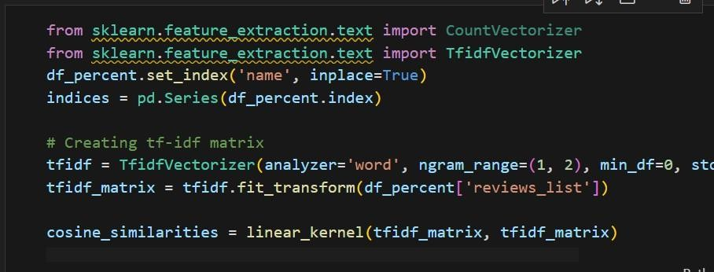
Model Validation and Evaluation Report (5 marks):

Model | Summary | Training and Validation Performance Metrics
Model 1 | Content-based Recommendation | Training Metrics -None (unsupervised, no explicit training phase)  Validation Metrics - None (recommendations are inspected manually)

